**PURPOSE:** Admittance abilities are important for nursing program candidates. The TEAS (Test of Essential Academic Skills) was developed to measure basic essential skills in the academic areas of Reading, Mathematics, Science and English. Metropolitan Community College (MCC) requires all applicants to the LPN (Level Practical Nurse) and RN (Registered Nurse) programs to complete the ATI TEAS exam within 3 years of the application deadline. (**Note:** The Nursing Entrance Test (NET) is no longer a valid entry exam at MCC.)

**At your appointment you must know your ATI username and password, bring a valid government issued photo ID (such as a drivers license, state ID card, or passport), and a copy of your receipt showing you paid your TEAS exam fee of $70.**

**WHAT IT IS:** The ATI TEAS exam is comprised of 170 questions that are formatted as multiple-choice items with 4 answer options and alternate-type items. This includes 150 scored questions and 20 unscored pretest questions. Students have 209 minutes (about 3 and a half hours) to complete the exam.

Students testing after June 03rd, 2022, will complete the **ATI TEAS Exam Version 7**.

The number of questions in each content section and subsection are as follows:

|  |  |  |
| --- | --- | --- |
| **Content Area** | **Number of Questions** | **Amount of Time Allowed** |
| **Reading** | 45 | 55 minutes |
| **Math (CALCULATOR embedded in program)** | 38 | 57 minutes |
| **Science** | 50 | 60 minutes |
| **English** | 37 | 37 minutes |
| **Total** | 170 | 209 minutes (about 3 and a half hours) |

**HOW TO PREPARE:** All applicants should review the study manual to prepare for the test. Study manuals for the ATI TEAS are available at the Library, the Learning and Tutoring Center, purchase from MCC Bookstores, or ATI publishing (<https://atitesting.com/teas/study-manual>). Online practice packages are also available for purchase from ATI at various prices (<https://atitesting.com/teas/smart-prep-tutorial>).

**WHEN SHOULD THE TEST SHOULD BE TAKEN:** Students must complete the test prior to the application deadline and are recommended to schedule to take the test at least 45 days (about 1 and a half months) prior to the announced Nursing Application deadline. This will allow adequate time to take a retake exam (if needed).

Applicants are permitted to take one (1) retake but must wait at least 30 days (about 4 and a half weeks) before making a second attempt. TEAS testing should be completed after finishing the general education courses that correlate to the associated TEAS testing content areas.

**\*\* ALLOW YOURSELF 4 HOURS FOR TESTING \*\***

**MAKE YOUR APPOINTMENT TO SIT FOR THE TEAS TEST:** You must schedule your testing date at least 48 business hours (about 2 days) in advance or earlier by calling or emailing:

**Elkhorn Valley Testing Center** [**testingcenterevc@mccneb.edu**](mailto:testingcenterevc@mccneb.edu) **Room 158 531-622-1278**

**Fort Omaha Testing Center** [**testingcenterfoc@mccneb.edu**](mailto:testingcenterfoc@mccneb.edu) **Building 23, Room 311 531-622-2204**

**South Omaha Testing Center** [**testingcentersoc@mccneb.edu**](mailto:testingcentersoc@mccneb.edu) **Connector Bldg. Room 102 531-622-4613**

**COST FOR THE TEST:** **$70 (per exam).**

Exam fee must be paid prior to taking a test.

**To pay for your TEAS exam:**

You may pay your TEAS $70 exam fee on-campus at Student Services – Cashiering, during their hours of operation. Be aware the Cashiering office may not be available to make a same day cash or credit/debit card payment.

If you would like to pay for testing over a telephone using a debit or credit card only.

1. Call the Student Accounts Office at 531-622-2405 (7:30 - 5:00 Monday - Friday) and state you need to pay for a TEAS exam. Please have your MCC student ID # ready.
2. The Student Accounts Staff Member will ask you several questions. You will provide your credit/debit card information to pay the $70 exam fee.
3. Remember to ask for a Payment Receipt Number from the Student Accounts Staff Member before disconnecting.
4. Copy this number down or bring your printed receipt to your TEAS exam appointment.

**RETAKE POLICY: $70 (per exam).** Applicants ***must wait at least a full 30 days (about 4 and a half weeks)*** before retaking the TEAS Exam. Retakes are scheduled the same way as one would schedule a first-time test.

*The TEAS exam can be completed twice within a three-year period. This is non-negotiable *

SCORING: Scores are calculated automatically and are available upon test completion. For applicant consideration into the TEAS program, *candidates must receive a minimum score of 50% in each subject content area*.

***ONLY THE MOST RECENT SCORES ARE USED FOR SELECTION PURPOSES.***

**QUESTIONS MAY BE DIRECTED TO:**

**Jennifer Hank Health Careers Enrollment Specialist SOC MHY 519 531-622-4791** [**jhank@mccneb.edu**](mailto:jhank@mccneb.edu)

***Ricki Christensen Nursing Program Director SOC MHY 531-622-4787*** [***rlchristensen5@mccneb.edu***](mailto:rlchristensen5@mccneb.edu)

**BEFORE TEST DAY:** If you are not a current ATI user, go to [**https://www.atitesting.com/**](https://www.atitesting.com/) and create an account. If you already have an ATI account, make sure you change the institution to **Metropolitan CC ADN NE**.

Once you have an ATI Account, you will have access the **ATI Student Portal** to take your TEAS Exam, access score reports (following the TEAS exam), send transcripts/scores to other educational institutions, and more.

**Test takers must create an “ATI Student Account” (*prior)* to the day of their exam.**

**To create an ATI Account, follow the next set of instructions and Step by Step Video:**

Note: When asked for your **Institution** you will select: **Metropolitan CC** **ADN NE**

**Go to the Step-by-Step Video: <https://vimeo.com/586466974?share=copy>**

[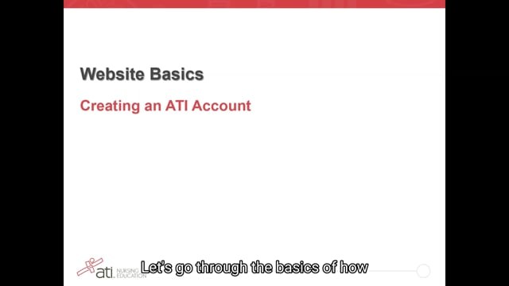](https://vimeo.com/586466974?share=copy)

**Step-by-Step student account creation instructions below:**

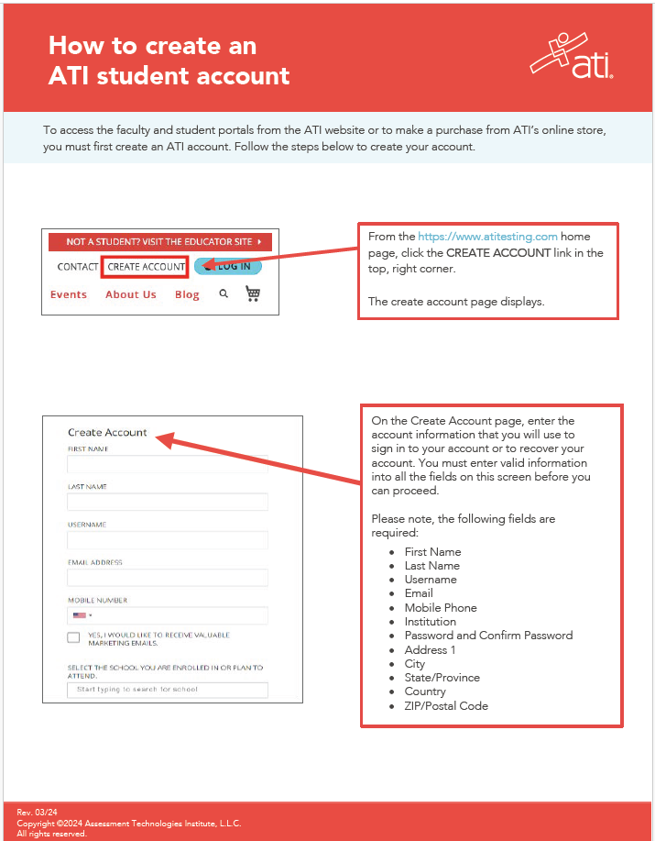

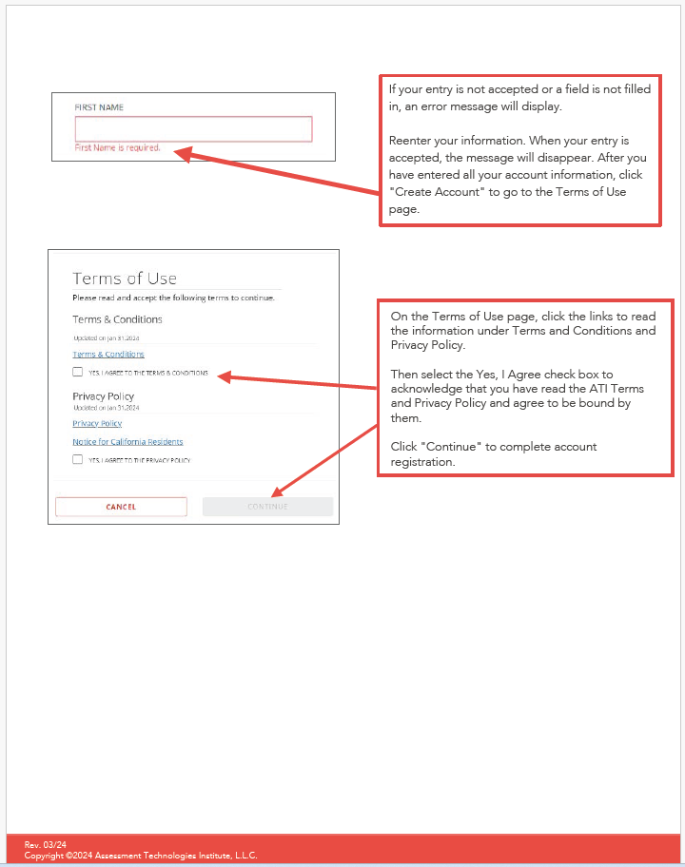

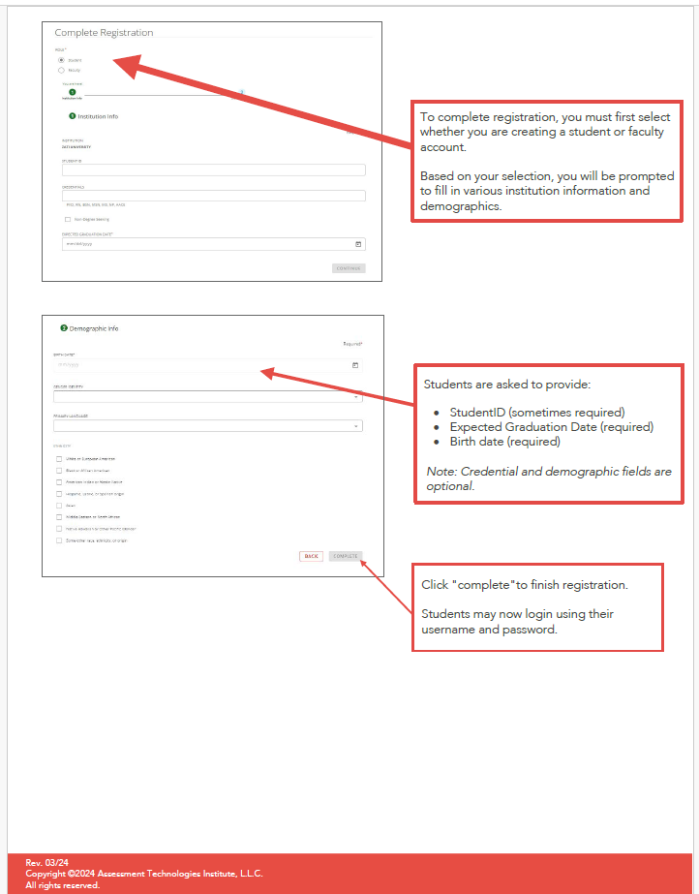

**TEAS Study Guide Resources**

***TEAS STUDY RESOURCES:*** Please check with the Library or the Learning and Tutoring Center (LTC) of your choice to see if they have printed study material available to “Check-out” for take home study or if it is “Reserved” for in-house use only.  **NOTE:** ***Library study materials that can be checked-out are for a maximum of 28 days (about 4 weeks) only. Learning and Tutoring Center materials cannot be checked out but can be used in the Learning and Tutoring Center.***

**ATI TESTING: TEAS Study Manual (2022-2023) –** **<https://atitesting.com/teas/study-manual>**

**ATI TEAS Smart Prep Tutorial** **–** **<https://atitesting.com/teas/smart-prep-tutorial>**

**ATI TEAS Online Practice Assessment –** [**https://atitesting.com/teas/practice-assessment**](https://atitesting.com/teas/practice-assessment)

***Additional Online Resources (not affiliated with ATI): (both databases are available on the following websites & can be accessed off-campus with an MCC username/password)***

**Library -** <https://www.mccneb.edu/Current-Students/Student-Tools/Library/Databases/Databases-Study-Guides.aspx> **(**for the **LearningExpress Library** you will need to create a free account for access, then type “teas” in the search box) (for the **Mometrix eLibrary**, just type “teas” in the search box)

**LTC -** <https://academy-pq.app.testprepreview.com/practicequestion/products/TEAS7>