Release of Unofficial Transcript

Instructions:

Current students who require an unofficial transcript can print a copy from their self-service portal.

Former students who are requesting a copy of their unofficial transcript must complete this form. Their wet signature is required. They have the option of having their transcript mailed or faxed.

If a student has contacted an area other than Student Services or the Registrar’s office for an unofficial transcript, please either give or email them the unofficial transcript request form or direct them to any Student Services location, the Career and Academic Skills Center or to the Registrar’s office (only if the student indicates that they wish to pick one up in person).

In person requests: Students who request a copy of their unofficial transcript at a Student Services location do not need to complete this form; however, they must present a valid photo ID.

Note: Only the Registrar’s office will mail, fax, or email the unofficial transcript to the student.

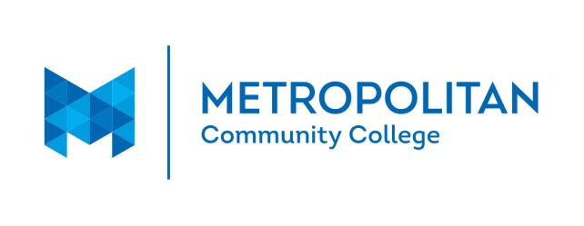
Release of Unofficial Transcript

Current students who require an unofficial transcript can print a copy from their self-service portal. Request received from current students will not be processed.

Former students who are requesting a copy of their unofficial transcript please complete all sections of the form. Wet Signature is required.

I am requesting that a copy of my unofficial transcript be released to me:

Mailed to me
OR
Faxed to me
OR
Emailed to me

I am requesting/authorizing MCC to release my unofficial transcript to a non-MCC email address.

Please email to the address indicated: _______________________________________________

Full Name (Printed): _______________________________________________________________

MCC Student ID # _______________________________________________________________

Phone number: _______________________________________________________________

Fax Number: ______________________________________________________________

Mailing address: _______________________________________________________________

City, State, Zip: _______________________________________________________________

Wet Signature (required): _____________________________________ Date__________________

Students may email this form to transcripts@mccneb.edu, or mail it to:
Metropolitan Community College, Registrar’s Office, P.O. Box 3777, Omaha NE 68103.
The Registrar’s office will fax, email, or mail the unofficial transcript.

