PURPOSE: Admittance abilities are important for nursing program candidates. The TEAS was developed to measure basic essential skills in the academic areas of Reading, Mathematics, Science and English. Metropolitan Community College (MCC) requires all applicants to the LPN and RN programs to complete the ATI TEAS exam within 3 years of the application deadline. (Note: The Nursing Entrance Test (NET) is no longer a valid entry exam at MCC.)

WHAT IT IS: The ATI TEAS exam is comprised of 170 questions that are formatted as both multiple choice items with 4 answer options and alternate-type items. This includes 150 scored questions and 20 unscored pretest questions. Students have 209 minutes to complete the exam.

For students testing on or after June 03, 2022, will complete the ATI TEAS exam version 7. The number of questions in each content section and subsection are as follows:

Content Area | Number of Questions | Amount of Time Allowed
Reading | 45 | 55 minutes
Math (CALCULATOR embedded in program) | 38 | 57 minutes
Science | 50 | 60 minutes
English | 37 | 37 minutes
Total | 170 | 209 minutes

HOW TO PREPARE: All applicants should review the study manual to prepare for the test. Study manuals for the ATI TEAS are available at the Library, the Learning and Tutoring Center, purchase from MCC Bookstores, or ATI publishing (https://atitesting.com/teas/study-manual). Online practice packages are also available for purchase from ATI at various prices (https://atitesting.com/teas/smart-prep-tutorial).

WHEN THE TEST SHOULD BE TAKEN: Students must complete the test prior to the application deadline and are recommended to schedule to take the test at least 45 days prior to the announced Application Deadline. This will allow adequate time to take a Retake Exam (if needed). Applicants are permitted to take one (1) retake, but must wait 30 days before attempting it. TEAS testing should be completed after finishing the general education courses that correlate to the associated TEAS content areas.

MAKING A RESERVATION TO TAKE THE TEAS TEST: You must schedule your testing date at least 48 hours in advance or earlier by calling or emailing:

Elkhorn Valley Testing Center testingcenterevc@mccneb.edu Room 158 531-622-1278
Fort Omaha Testing Center testingcenterfoc@mccneb.edu Building 23, Room 311 531-622-2204
Sarpy Center Testing Center testingcentersrp@mccneb.edu Room 116 531-622-3803
South Omaha Testing Center testingcentersoc@mccneb.edu Connector Bldg. Room 102 531-622-4613

** ALLOW YOURSELF 4 HOURS FOR TESTING **

COST FOR THE TEST: $70 (per exam).
Exam fee must be paid prior to testing.
To pay for your TEAS exam:
You may pay your TEAS $70 exam fee on-campus at Student Services – Cashiering, during their hours of operation. Be aware the Cashiering office may not be available to make a same day cash or credit/debit card payment.
If you would like to pay for testing over a telephone using a debit or credit card only.
- Call the Student Accounts Office at 531-622-2405 (7:30 - 5:00 Monday - Friday) and state you need to pay for a TEAS exam. Please have your MCC student ID # ready.
- The Student Accounts Staff Member will ask you several questions. You will provide your credit/debit card information to pay the $70 exam fee.
- Remember to ask for a Payment Receipt Number from the Student Accounts Staff Member before disconnecting.
- Copy this number down or bring your printed receipt to your TEAS exam appointment.

RETAKE POLICY: $70 (per exam). Applicants must wait a full 30 days before retaking the TEAS. Retakes are scheduled the same way as one would schedule a first-time test.

*The TEAS exam can be completed twice within a three-year period. This is non-negotiable *

SCORING: Scores are calculated automatically and are available upon test completion. For applicant consideration into the TEAS program, candidates must receive a minimum score of 50% in each subject content area. ONLY THE MOST RECENT SCORES ARE USED FOR SELECTION PURPOSES.

QUESTIONS MAY BE DIRECTED TO:
Jennifer Hank Health Careers Enrollment Specialist SOC MHY 519 531-622-4791 jhank@mccneb.edu
Nancy Pares Director of Nursing SOC MHY 513 531-622-4787 npares@mccneb.edu

BEFORE TEST DAY: Test takers must create a “Users Account” on the ATI website (https://www.atitesting.com/) and bring their username and password for this account with them prior to the day of their exam. To do this:
How to Create a New ATI Account in preparation for the TEAS
If you are not a current user on https://www.atitesting.com/, you must create a new account to access the student portal to take your TEAS exam, complete the dry run for remote proctored online TEAS exams, access score reports following your TEAS exam, send transcripts, and much more.
Follow the steps below to create a new account.
Note: When asked for your Institution below you will select: Metropolitan CC ADN NE
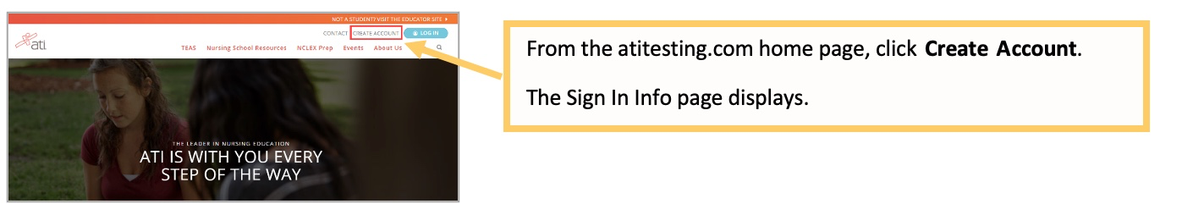
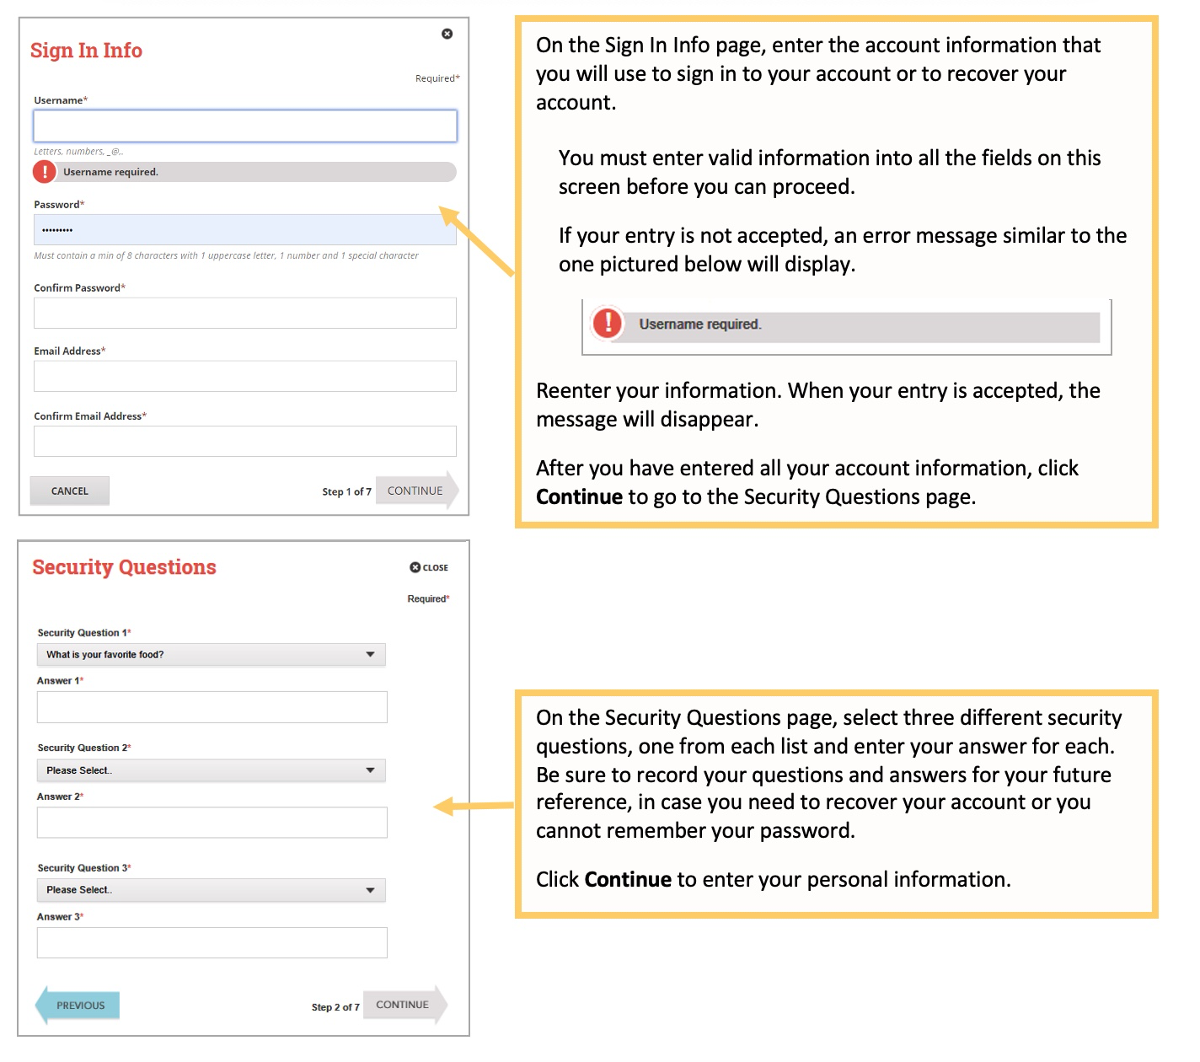
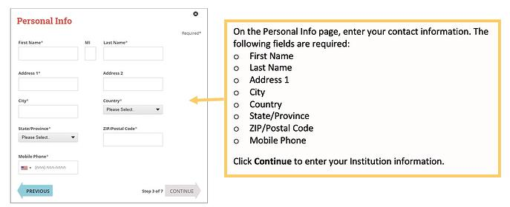
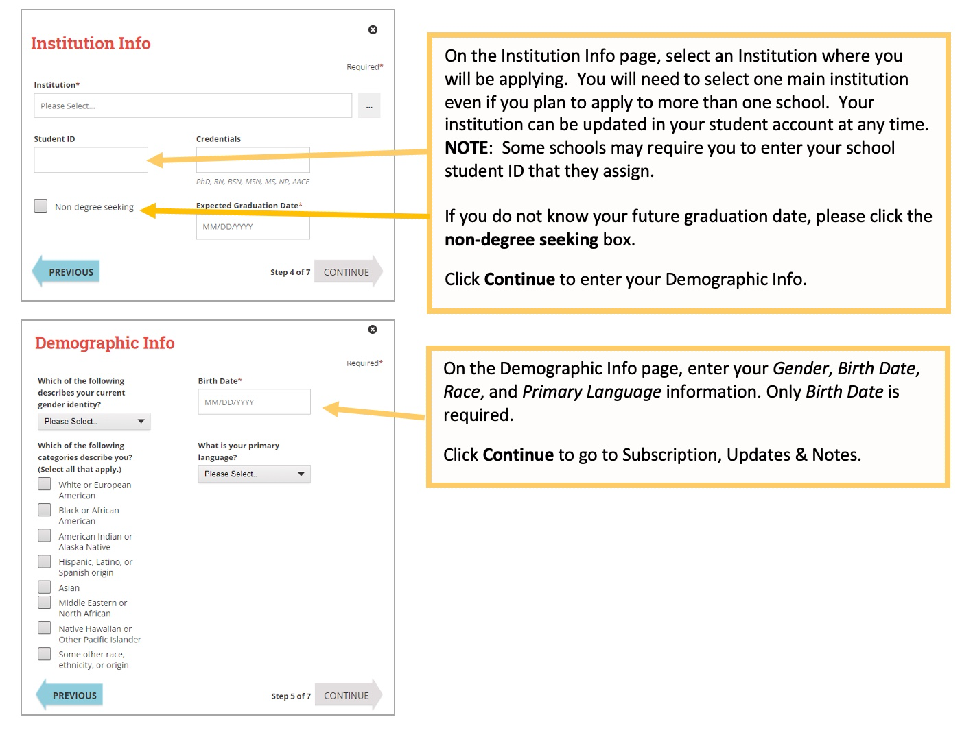
For Institution select:
Metropolitan CC ADN NE

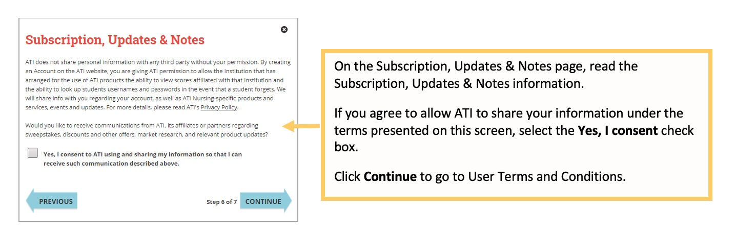
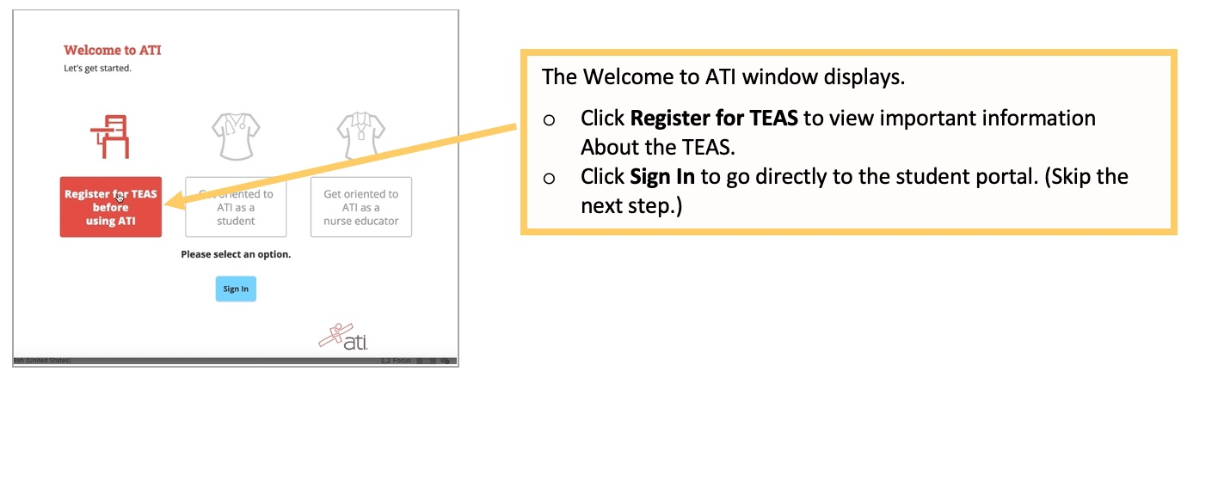
TEAS Study Guide Resources

TEAS STUDY RESOURCES: Please check with the Library or the Learning and Tutoring Center (LTC) of your choice to see if they have printed study material available to “Check-out” for take home study or if it is “Reserved” for in-house use only. NOTE: Library study materials that can be checked-out are for a maximum of 28 days only. Learning and Tutoring Center materials are available on a first come, first serve basis for in house use only.

ATI TESTING: TEAS Study Manual (2022-2023) – https://atitesting.com/teas/study-manual
ATI TEAS SmartPrep Tutorial – https://atitesting.com/teas/smart-prep-tutorial
ATI TEAS Online Practice Assessment – https://atitesting.com/teas/practice-assessment

Additional Online Resources (not affiliated with ATI):
LearningExpress Library: You will need to create a free account for access. Then type “teas” in the search box.
Mometrix eLibrary: Type “teas” in the search box.

Both databases are available on the following websites & can be accessed off-campus with an MCC username/password:

Library - https://www.mccneb.edu/Current-Students/Student-Tools/Library/Databases/Databases-Study-Guides.aspx
LTC - https://www.mccneb.edu/Current-Students/Student-Tools-Resources/Learning-and-Tutoring-Centers/Resource-Links.aspx

