Enrollment Verification Request

For Loan or Financial Deferment questions/verifications, contact the Financial Aid office 531-622-2330.
Instructions: The Enrollment Verification Form is completed, signed and forwarded to the Records office for processing of verification EXCEPTIONS. All MCC degree verifications and most enrollment verifications (term start/end dates only) are processed through the National Student Clearinghouse (NSC). Only directory information is provided, unless the student specifically checks the non-directory options.
The NSC provides instant 24/7 confirmation of enrollment to employers/employment agencies and other organizations; these agencies need to be referred to the NSC's website.
Students may also request enrollment verifications through the NSC for requests that are not on the Enrollment Verification exceptions list. Go to www.studentclearinghouse.org, then click on Order or Track-Verify (a printer is needed).
Allow five business days to process.
Questions? Contact a Records Representative at 531-622-2353 or records@mccneb.edu. The Records office is located on the Fort Omaha Campus, Building 5.

Enrollment Verification Request Form
PLEASE SUBMIT A SEPARATE FORM FOR EACH REQUEST SENT TO RECORDS
Print clearly and allow FIVE business days to process
Official verifications are processed after quarter begins
Verifications submitted in writing before the start date of quarter will be processed as “Pre-registered”

Date

Please check term & type of information requested. Only directory information provided unless a non-directory option is checked.
Current Term Previous Terms Only All Terms Attended
Academic Standing GPA Verification Total Credit Hours Earned Projected graduation date

Enrollment Verification processed for the following ONLY and will be sent directly to company or agency
For all other verifications, go to National Student Clearinghouse website @ www.studentclearinghouse.org

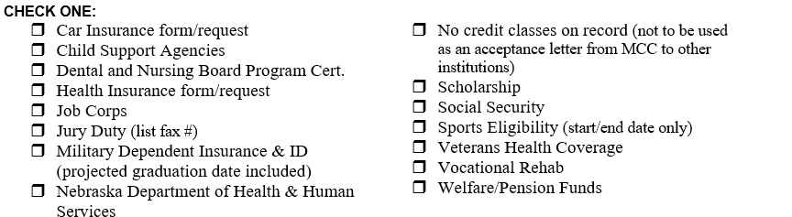

Name Student Signature Please PRINT your LEGAL name (Required)
Current Street Address
City State Zip Telephone
MCC ID #

Verification Mailing Address/Fax number (Please PRINT clearly and verify mailing information with recipient)

Send To Attention

Address

City State Zip

Fax #

