If you forgot your password or need to unlock your account, go to https://myapps.mccneb.edu and click the Need help signing in? link to display Forgot password and Unlock account options.
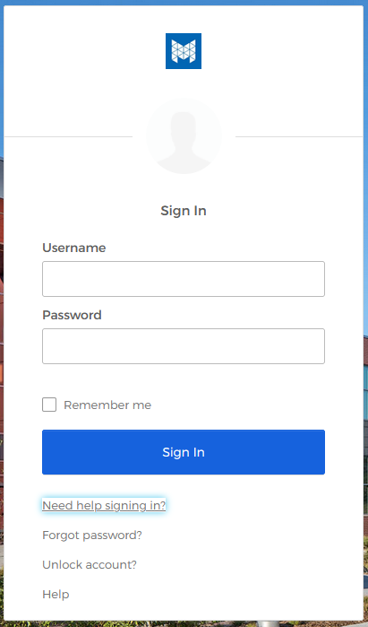
If you forgot your password and need to reset it, click the Forgot password link.
If your account is locked, you can unlock it yourself. Select the Unlock account link.

PASSWORD RESET:
If you forgot your password, select the Forgot password link. Enter your username and select the button for the method you would like to use to reset your password (Reset via SMS text message, Reset via Voice Call, or Reset via Email).
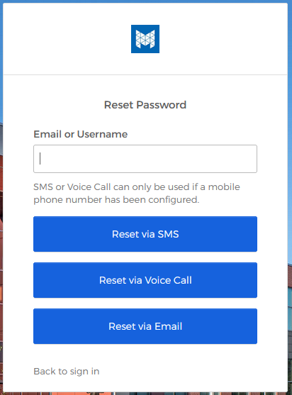

Reset via SMS:
Clicking this option will automatically generate and send a 6-digit verification code text message to your enrolled mobile phone number, and will display the following screen:
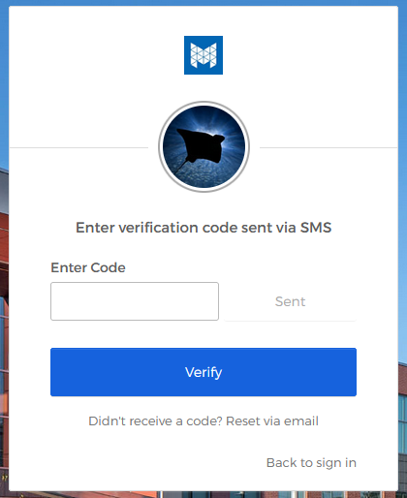
Enter the verification code you receive via text message on your mobile phone in the box and click Verify.

You will then be prompted to answer your Forgotten Password Challenge question. Answer the security question and click Reset Password:
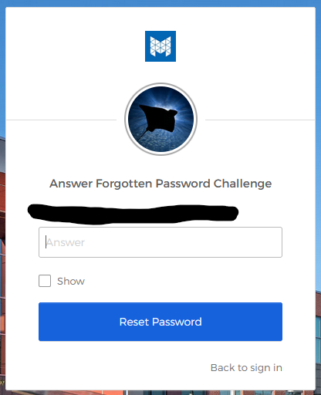

Enter your new password, ensuring that you follow the password requirements listed on the reset password screen (see below) and click Reset Password:
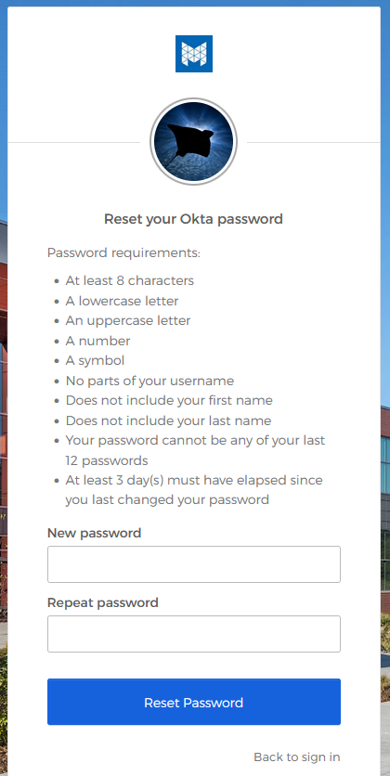
It will take a few seconds, but once your password has been successfully reset, you will be taken to the Okta User Homepage:
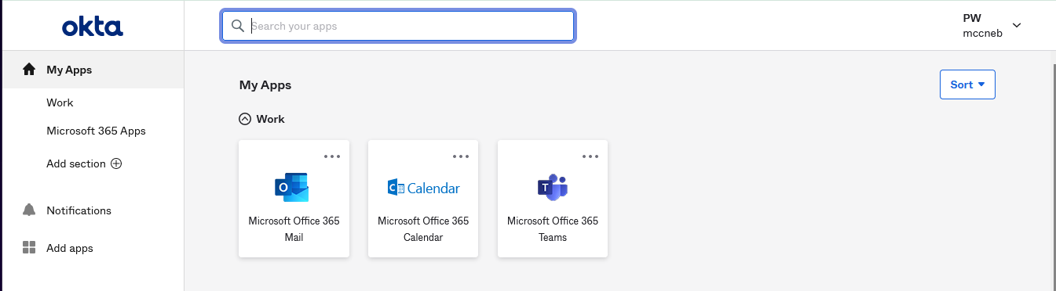

Reset via Voice Call:
When clicking this option, you will receive an automated phone call from 872-278-8883 (a Chicago, IL phone number) at your enrolled phone number with an auto-generated 5-digit verification code, and will display the following screen:
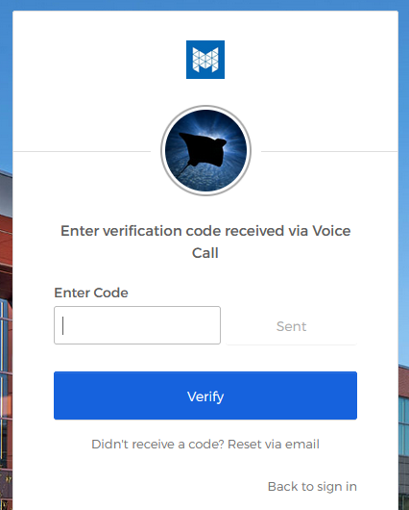
Enter the verification code provided during the phone call and click Verify.

You will then be prompted to answer your Forgotten Password Challenge question. Answer the security question and click Reset Password:
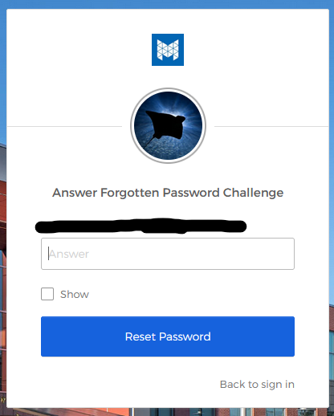

Enter your new password, ensuring that you follow the password requirements listed on the reset password screen (see below) and click Reset Password:
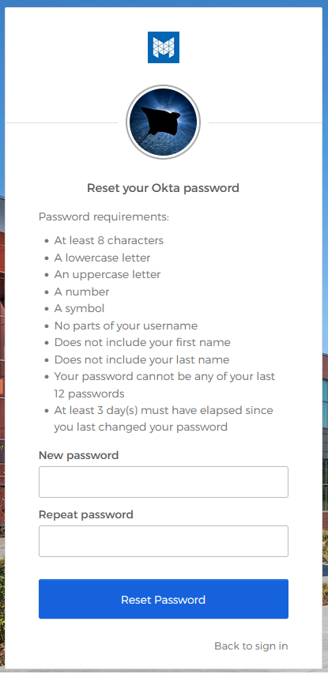
It will take a few seconds, but once your password has been successfully reset, you will be taken to the Okta User Homepage:

Reset via Email:
When clicking this option, you will receive an email from Okta (noreply@okta.com) at both your MCC email and secondary email addresses. and the following screen will be displayed:
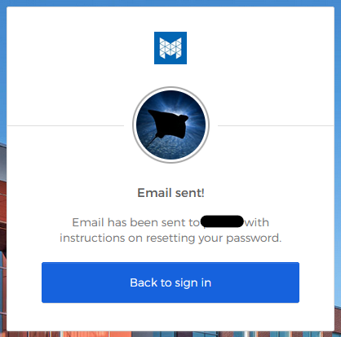

If you have forgotten your password, you most likely will not be able to access your MCC email. You will need to login to your secondary email account and follow the directions in the email from Okta (noreply@okta.com) in order to reset your password. A sample email is shown below:
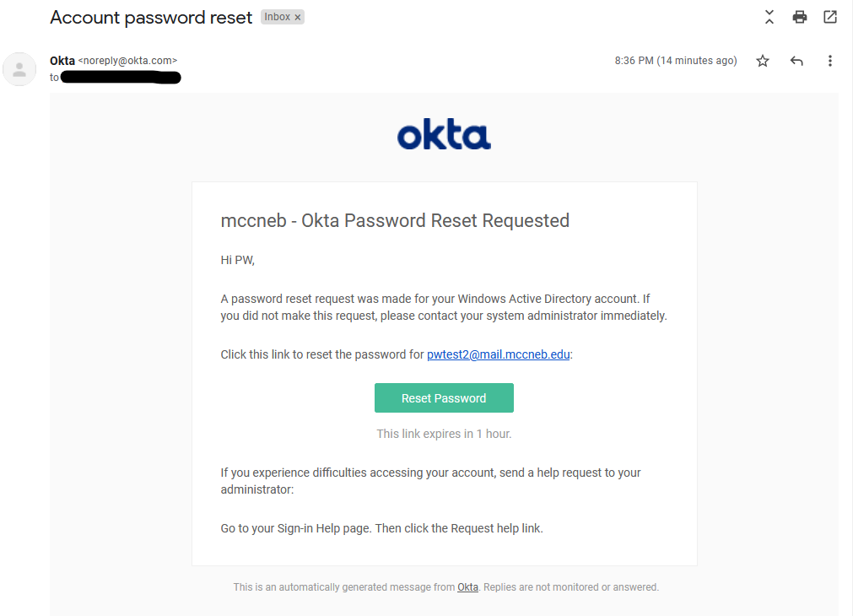
Click the Reset Password button in the Okta (noreply@okta.com) email. You will be taken to https://myapps.mccneb.edu and you will be prompted to answer your Forgotten Password Challenge question. Answer the security question and click Reset Password:
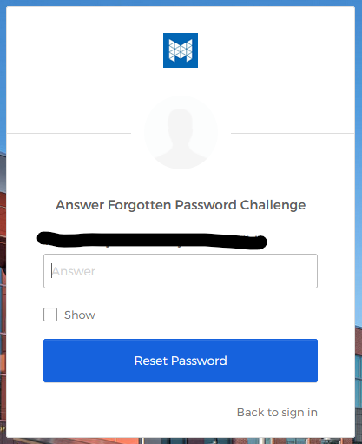
Enter your new password, ensuring that you follow the password requirements listed on the reset password screen (see below) and click Reset Password:

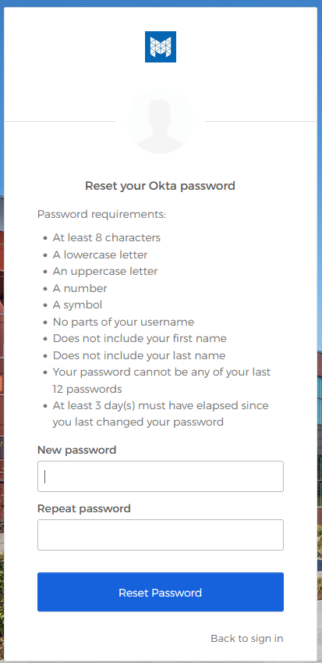
It will take a few seconds, but once your password has been successfully reset, you will be taken to the Okta User Homepage:

UNLOCK ACCOUNT:
Select the Unlock account link. Enter your username and select the button for the method you would like to use to unlock your account.
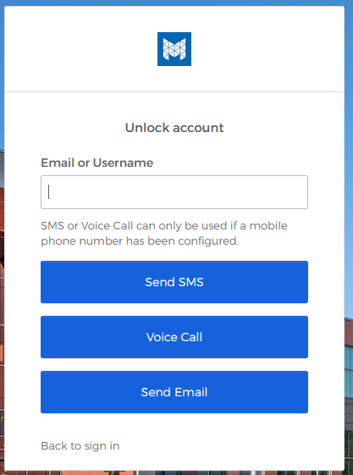

Unlock via SMS:
Clicking this option will automatically generate and send a 6-digit verification code text message to your enrolled mobile phone number, and will display the following screen:

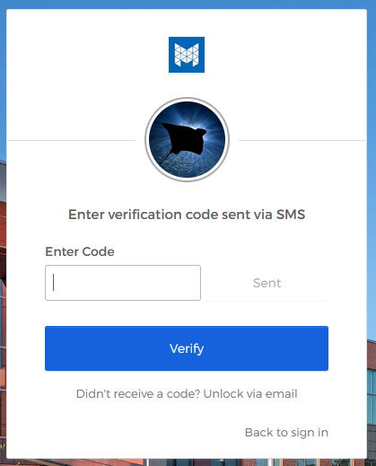
Enter the verification code you receive via text message on your mobile phone in the box and click Verify.

You will then be prompted to answer your Unlock Account Challenge question. Answer the security question and click Unlock Account:

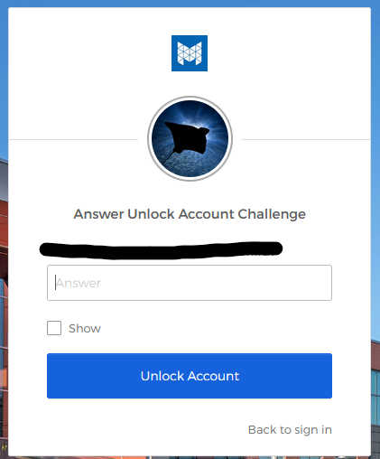

Your account has now been successfully unlocked and you should now be able to login without issues.
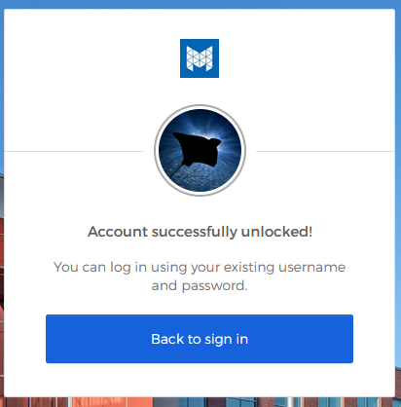

Unlock via Voice Call:
When clicking this option, you will receive an automated phone call from 872-278-8883 (a Chicago, IL phone number) at your enrolled phone number with an auto-generated 5-digit verification code, and will display the following screen:
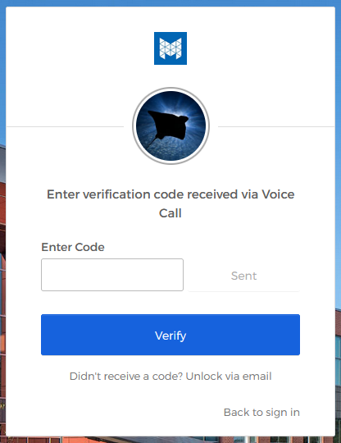
Enter the verification code provided during the phone call and click Verify.

You will then be prompted to answer your Forgotten Password Challenge question. Answer the security question and click Reset Password:

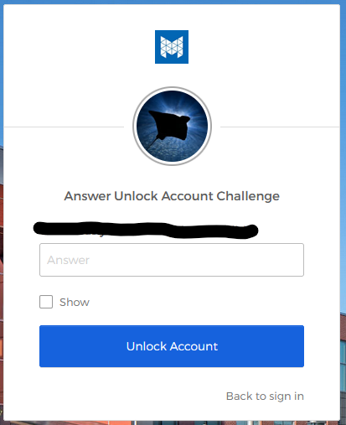

Your account has now been successfully unlocked and should now be able to login without issues.
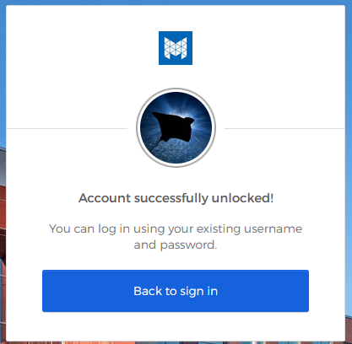

Unlock via Email:
When clicking this option, you will receive an email from Okta (noreply@okta.com) at both your MCC email and secondary email addresses. and the following screen will be displayed:
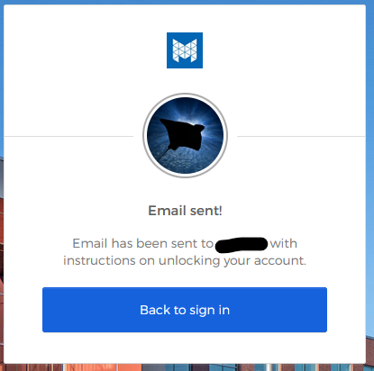
If your account is locked, you most likely will not be able to access your MCC email. You will need to login to your secondary email account and follow the directions in the email from Okta (noreply@okta.com) in order to unlock your account. A sample email is shown below:
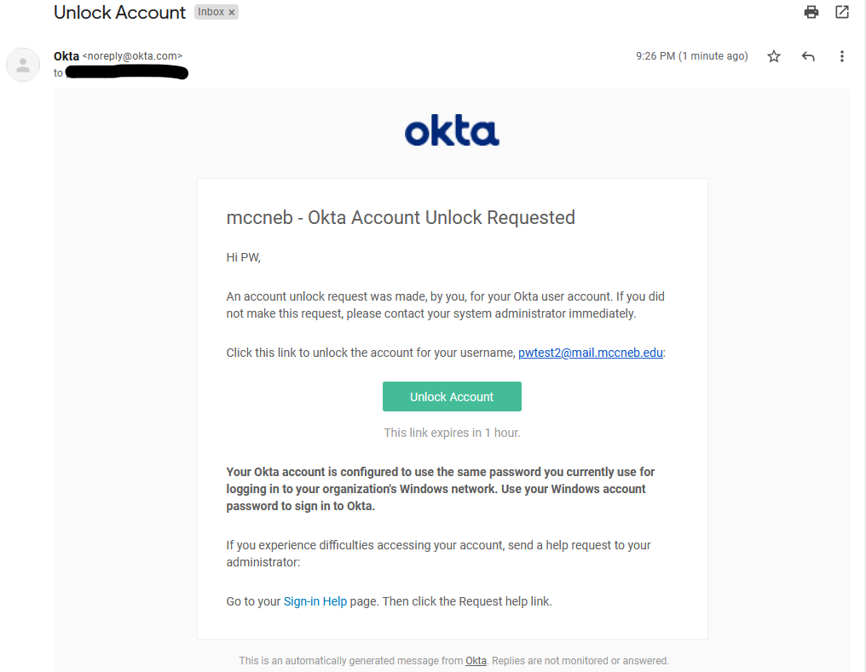
Click the Unlock Account button in the Okta (noreply@okta.com) email. You will be taken to https://myapps.mccneb.edu and you will be prompted to answer your Unlock Account Challenge question. Answer the security question and click Unlock Account:
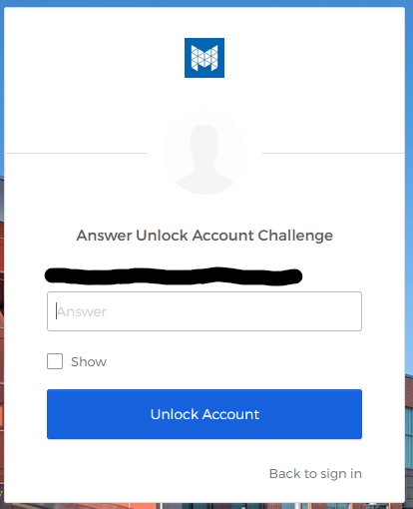

Your account has now been successfully unlocked and should now be able to login without issues

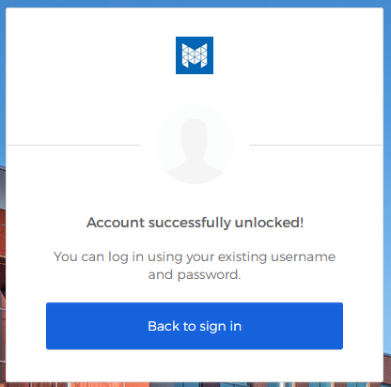

TROUBLESHOOTING:
If you receive the following message when you try to reset your password stating that you do not have permission to perform the requested action, it may be because you have already recently reset your password.
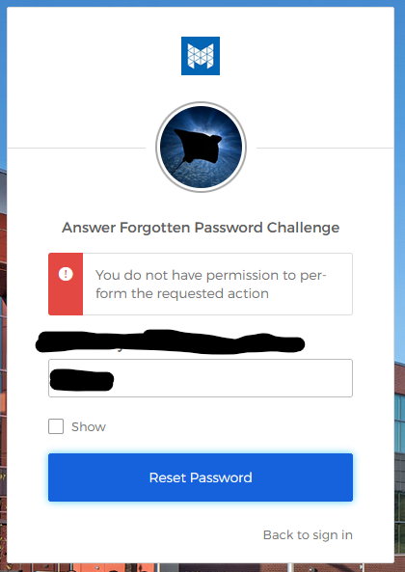
Wait a few minutes and try resetting your password again.

