Release of Unofficial Transcript or Course Schedule Form

Due to the coronavirus outbreak and the need for social distancing, mail will only be retrieved and processed once a week. Responses will be delayed by a minimum of two weeks.

Instructions:

Current students who require an unofficial transcript or their class schedule can print a copy from their self-service portal.

Former students who are requesting a copy of their unofficial transcript must complete this form. Their signature is required. They have the option of having their transcript mailed.

If a student has contacted an area other than Student Services or the Records office for an unofficial transcript, please either give or email him/her the unofficial transcript request form.

Note: Only the Records office will mail the unofficial transcript to the student.

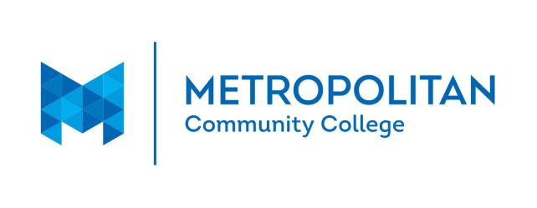

Release of Unofficial Transcript or Course Schedule

I am requesting that a copy of my unofficial transcript be released to me:

Mailed to me (Current students: Must access unofficial transcripts & schedule through student self-service portal.)

Name (Printed): _______________________________________________________________

MCC Student ID #______________________________________________________________

Mailing address: _______________________________________________________________

Address: _____________________________________________________________________

City, State, Zip: ________________________________________________________________

Signature (required): _____________________________________ Date__________________

Students may email this form to transcripts@mccneb.edu, or mail it to: Metropolitan Community College, Records Office, P.O. Box 3777, Omaha NE 68103.
The Records office will mail the unofficial transcript.

