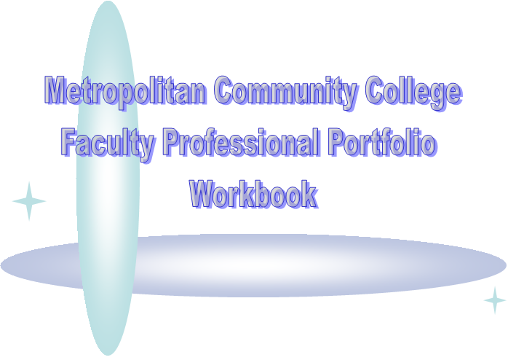

Table of Contents

What Is A Portfolio? | 3
Additional Guidelines for the Development of Your Portfolio | 4
Writing Your Teaching Philosophy Statement: Year 1 | 4
Writing Your Reflective Narratives: Subsequent Years | 5
Descriptions of the Three Major Focus Areas | 6
Portfolio Development Checklist | 9
What is a portfolio?
A professional portfolio is a collection of documents that you will submit as you continue in your career as an instructor at the college. This type of portfolio should include a record of your teaching experience and accomplishments, your professional development activities, and your record of college/community service. Professional portfolios can be either summative – created for the purpose of applying for a job or for promotion within a department, or formative -- created for the purpose of ongoing personal and professional development. In this case, your portfolio is formative. In addition, your portfolio will contain a written narrative that reflects your teaching philosophy and your thoughts about your work and your progress as an instructor at the college.

According to the College’s document of Professional Expectations of Full-Time Faculty Members, there are three major areas of annual performance review for faculty members: teaching, professional development, and program/college/community involvement.
During the first year of portfolio development, you will be focusing on creating a teaching philosophy statement and collecting artifacts for the three major areas. The artifacts should support the main points you made in your philosophy statement. In subsequent years, you will be submitting a written reflective narrative on your work over the past year. The written narrative should place special emphasis on the chosen focus area, but may also include discussion of the other two areas as necessary to reveal a complete picture of past work. Thus, full development of your portfolio will be completed in 4 years (See figure 1). Your portfolio will be used as a means of self-reflection and a point of discussion during your annual performance review.
Figure 1
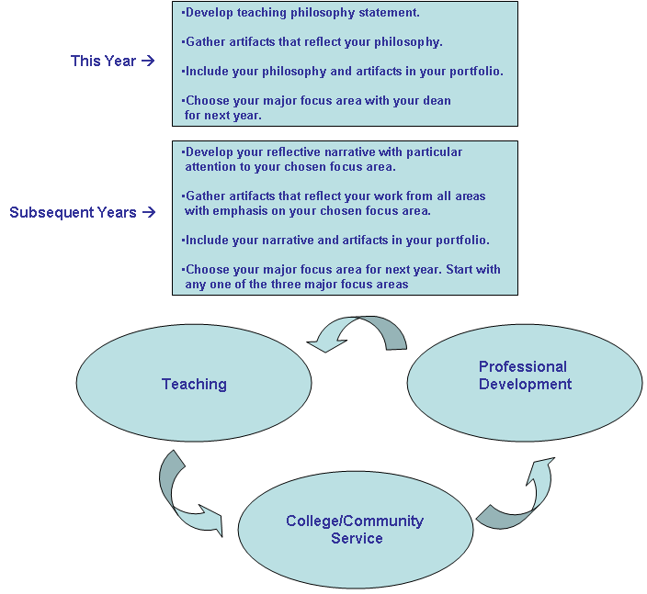

Additional guidelines for the development of your portfolio

- Your portfolio development should be a continuing process.
- Your portfolio should be available by the time you meet with your dean in the spring.
- You should prepare a table of contents for your portfolio that lists all the artifacts in the portfolio. The table of contents should be the first page of your portfolio
- Your teaching philosophy statement (year 1) or your reflective narrative (subsequent years) must be part of the portfolio.
- Your portfolio is your property. However, copies of the portfolio should be made available to the dean upon request.

Writing your teaching philosophy statement: Year One *

A philosophy of teaching statement is a narrative that includes
- your conception of teaching and learning
- a description of how you teach
- justification for why you teach that way
The statement can
- demonstrate that you have been reflective and purposeful about your teaching
- communicate your goals as an instructor and your corresponding actions in the classroom
- provide an opportunity to point to and tie together the other sections of your portfolio

What is the purpose of developing a philosophy of teaching? *

It has been recognized by many teachers that the process of identifying a personal philosophy of teaching and continuously examining, testifying, and verifying this philosophy through teaching can lead to change of teaching behaviors and ultimately foster professional and personal growth.

General formatting suggestions
- There is no required content or set format. There is no right or wrong way to write a philosophy statement. You may decide to write in prose, use famous quotes, create visuals, use a question/answer format, etc.
- It is generally 1-2 pages in length. For some purposes, an extended description is appropriate, but length should suit the context.
- Use present tense, in most cases. Writing in first-person is most common and is the easiest for your audience to read.
- Most statements avoid technical terms and favor language and concepts that can be broadly appreciated. A general rule is that the statement should be written with the audience in mind. It may be helpful to have someone from your field read your statement and give you some guidance on any discipline-specific jargon and issues to include or exclude.
- Include teaching strategies and methods to help people “see” you in the classroom. Help your reader to visualize what you do in the classroom and the exchange between you and your students. For example, can your readers picture in their minds the learning environment you create for your students?
- Make it memorable and unique. What is going to set you apart? What about you are they going to remember? What brings a teaching philosophy to life is the extent to which it creates a vivid portrait of a person who is intentional about teaching practices and committed to his/her career.
- “Own” your philosophy. By writing about your experiences and your beliefs, you “own” those statements and appear more open to new and different ideas about teaching. Even in your own experience, you make choices as to the best teaching methods for different courses and content: sometimes lecture is most appropriate; other times you may use service-learning, for example.
As you begin writing, ask yourself and answer the following questions:
- How do I think learning occurs?
- How can I facilitate this process? How have I come to these conclusions?
- What goals do I have for my students?
- What do I do to implement my plans/intentions?
- What goals have I set for myself as an instructor?
There are no set parameters on the length of the philosophy statement. On average, it should be less than two type-written pages.
Writing your reflective narratives: Subsequent years
Reflection on one’s work is an integral part of any portfolio review. Thus, as part of the portfolio, the faculty member should submit a written reflective narrative on his/her work over the past year. The written narrative should place special emphasis on the chosen focus area, but may also include discussion of the other two areas as necessary to reveal a complete picture of past work. You will want to answer the following questions as part of your reflective narrative:

- What were your goals for the year in your focus area? How are these goals informed by your Philosophy of Teaching?
- In what specific ways were you able to meet your goals? (Refer to your portfolio artifacts when possible)
- In what ways did your work towards these goals contribute to your professional growth?
- What will be your focus area for next year? (Teaching, Professional development or Program/College/Community Service)
- What are your goals for next year? How are these goals informed by your Philosophy of Teaching?
- What plans do you have to implement your goals?
There are no set parameters on the length of the written reflection. On average, it should be less than two type-written pages.

Descriptions of the three major areas

Area 1: Teaching
The teaching section of your portfolio describes and documents multiple aspects of your teaching ability and experience. Teaching at Metro has been defined as being actively and enthusiastically engaged in facilitating learning, assessing/diagnosing learner needs, presenting information, facilitating learning experiences, and assessing/evaluating learner progress toward achieving learning goals/objectives.

Your teaching reflective narrative should describe your teaching experience and reflect your self-assessment of your teaching practice along these dimensions. You should state your teaching goals for the year, how your goals were informed by your Philosophy of Teaching, and in what specific ways you were able to meet your goals (refer to your portfolio artifacts when possible). In addition, describe how working toward your goals contributed to your professional growth.

You should also discuss what your focus area will be for next year (Teaching, Professional development or Program/College/Community Service), what your goals may be for next year, how these goals are informed by your Philosophy of Teaching, and what plans you have to implement your goals.

Supplement your reflective narrative with carefully chosen artifacts that reveal more detail about your teaching practice and support the points you made in your narrative.

Possible Portfolio Artifacts (not an exhaustive list)
- Completed Student Course/Feedback forms (minimum from 5 classes)
- Course Syllabi (minimum from 2 classes – syllabi should come from same classes of student evaluations)
- Completed student work (e.g., exam, papers, projects, etc.)
- Course material (e.g., handouts, videos, overheads, etc.)
- Professional development as related to teaching
- Correspondence from students, employers, community members, etc.
- Classroom observation feedback
- Personal journal or log
- Peer Reviews
- Honors/awards
- Your contribution to your program’s or department’s learning outcome measures
- Examples of your classroom assessment techniques
- Video of teaching
- Other examples that demonstrate your teaching expertise.
Area 2: Professional Development

Professional development encourages becoming a reflective practitioner who possesses a spirit of life-long learning. Professional development responsibilities include a wide range of individualized pursuits that can be proactive in maintaining expertise in a field of study and teaching practice.

Your professional development reflective narrative should describe your professional development activities for the year. You should describe what you learned and how you will incorporate your learning into your practice as an instructor, and/or use your experiences to attain your educational goals. You should state your professional development goals for the year, how your goals were informed by your Philosophy of Teaching, and in what specific ways you were able to meet your goals (refer to your portfolio artifacts when possible). In addition, describe how working toward your goals contributed to your professional growth.

You should also discuss what your focus area will be for next year (Teaching, Professional development or Program/College/Community Service), what your goals may be for next year, how these goals are informed by your Philosophy of Teaching, and what plans you have to implement your goals.

Supplement your reflective narrative with carefully chosen artifacts that reveal more detail about your professional development activities and support the points you made in your narrative.

Possible Portfolio Artifacts (not an exhaustive list)
- Evidence of professional organization activity (e.g., recent membership card, involvement with governing boards, etc.)
- Metro Community College or other college’s transcript of credit or non-credit courses completed
- Documented meetings with faculty in other programs
- Nationally recognized, up-to-date certificates
- Documentation of obtaining CEU’s.
- Evidence of attending regional or national conferences in field
- Presentations given at national or regional conferences
- Presentations given at Metro Community College faculty development days.
- Evidence of attending training seminars in your field
- Mentoring
- Other examples that demonstrate your professional development activities.

Area 3: Program, College, and Community Involvement

Faculty members are part of the college community and as such, have community responsibilities. Program, college, and community involvement embodies a zeal for the power of learning and requires a commitment to an exchange of professional ideals and expertise to address the needs of the College and the community for relevant, useful, and dynamic curriculum. Program, college, and community involvement activities foster better decision making within the College and enhance the image of the College in the community.

Your program, college, and community involvement reflective narrative should describe your activities and reflect your evaluation of how your activities address the college’s needs along these dimensions. You should state your program, college, and community involvement goals for the year, how your goals were informed by your Philosophy of Teaching, and in what specific ways you were able to meet your goals (refer to your portfolio artifacts when possible). In addition, describe how working toward your goals contributed to your professional growth.

You should also discuss what your focus area will be for next year (Teaching, Professional development or Program/College/Community Service), what your goals may be for next year, how these goals are informed by your Philosophy of Teaching, and what plans you have to implement your goals.

Supplement your reflective narrative with carefully chosen artifacts that reveal more detail about your involvement and support the points you made in your narrative.

Possible Portfolio Artifacts (not an exhaustive list)
- Participation in Advisory Committees (e.g., minutes of meeting)
- Work with Advisory Committee members outside of advisory meetings
- Involvement in local (four county area) professional associations
- Participation in program specific curriculum update activities (e.g., DACUM projects)
- Contribution to and/or update of outcomes assessment matrices.
- Participate in program and/or department meetings
- Documented service on college committees (e.g., committee minutes, etc.)
- Involvement in college fairs and/or career days attended
- Involvement in high school visits
- Involvement in community agencies (e.g., letter, minutes of meetings, etc.)
- Other examples that reveal your program/college/community involvement activities.

Portfolio Development Checklist: This Year

- Begin by writing your teaching philosophy

- During the academic year, collect artifacts that will demonstrate your performance in the three major areas (teaching, professional development, and program/college/community involvement) and that reflect your teaching philosophy. The contents of your portfolio will be determined by you but must include at least three artifacts from each major area. Recommendations for specific artifacts may also be made by your dean if appropriate.
- Prior to the end of the nine month academic year, you and your dean will discuss your portfolio at your annual review meeting. You will present your portfolio, discuss your past year’s performance, and talk about your goals for the next year.
After your portfolio review meeting the dean will sign off on the portfolio and make the appointment recommendation on the Annual Appointment Notice.

Portfolio Development Checklist: For the Next Three Years

- At the conclusion of the academic year in which you have developed your teaching philosophy statement, you will identify one of the three major areas (teaching, professional development, and program/college/community involvement) as your focus for the next year. This step will be completed in collaboration with your dean.
- During the next academic year, collect artifacts that will demonstrate your performance with an emphasis on your identified focus area and may also include artifacts from the other two areas as necessary to reveal a complete picture of past work. The contents of your portfolio will be determined by you but must include at least three artifacts from your focus area. Recommendations for specific artifacts may also be made by your dean if appropriate.
- After you have collected your artifacts, write a reflective narrative on your work during the year emphasizing the focus area that you identified with your dean (Teaching, Professional development, or Program/College/Community Involvement). Refer to your artifacts to support the major points you make in your narrative. Your narrative may also include discussion of the other two areas as necessary to reveal a complete picture of past work. Your reflective narrative should be no more than two pages in length.
- Prior to the end of the nine month academic year, you and your dean will discuss your portfolio at your annual review meeting. You will present your portfolio, discuss your past year’s performance, develop a set of goals for the next year, and choose your focus area for the next year.

* from http://ftad.osu.edu/portfolio/philosophy/Philosophy.html

