Steps to get to the work study application and to follow
- Click this link Metropolitan Community College | Search Jobs (mccnebjobs.com)
- Choose one of the 5 work study positions available (GENERAL, IT, HEALTH, ART, SCIENCE)
- Click view details on chosen field
- Press apply for this job
- Create an account
- Sign into your account
- Press apply to this job
- Fill out the application follow these steps to fill out application
- Fill out all the required elements on personal information sheet (for the where did I learn about this job fill in how you heard about work study if you found it on the financial aid website just list financial aid website)
- Press save and continue
- On the education sheet only fill out this part (skip all other parts)
- Press save and continue
- On the previous employment sheet only give your last employment information (filling in only the fields with a red *)
- Press save and continue
- Skip the documents needed to apply portion of the application (you can fill this in if you would like)
- Press save and continue
- Skip the references portion of the application (you can fill this in if you would like)
- Press save and continue
- Answer all questions on the supplemental questions part of the application shown below:
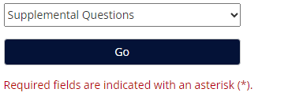
- Press save and continue
- Skip the Voluntary Self Identification of Disability part of the application (you can fill this in if you would like)
- Press save and continue
- Skip the Voluntary Self Identification of Protected Veteran Status part of the application (you can fill this in if you would like)
- Press save and continue
- Skip the Voluntary Demographic Information part of the application (you can fill this in if you would like)
- Press save and continue
- The application is complete now press certify and submit

